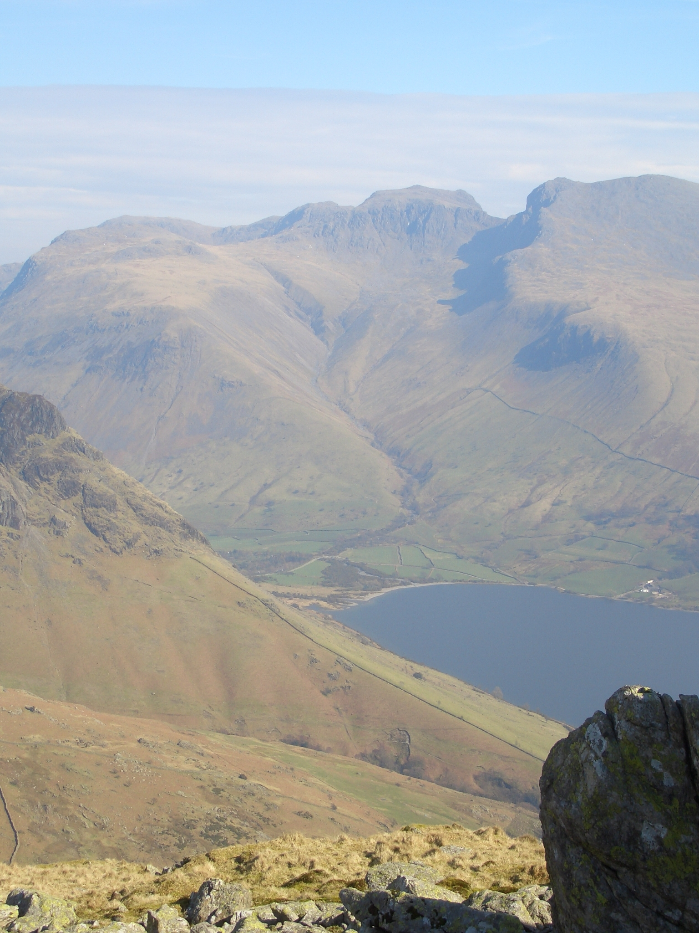
Mickledore

Lingmel Col
Scafell Pike Summit

Lingmel Summit
Scafell Summit
Brackenclose Bridge
‘Y’ Junction

Lingmell Gill Crossing
Footbridge
Wasdale Head Hall Farm

N
Scafell Pike from Brackenclose in Wasdale

