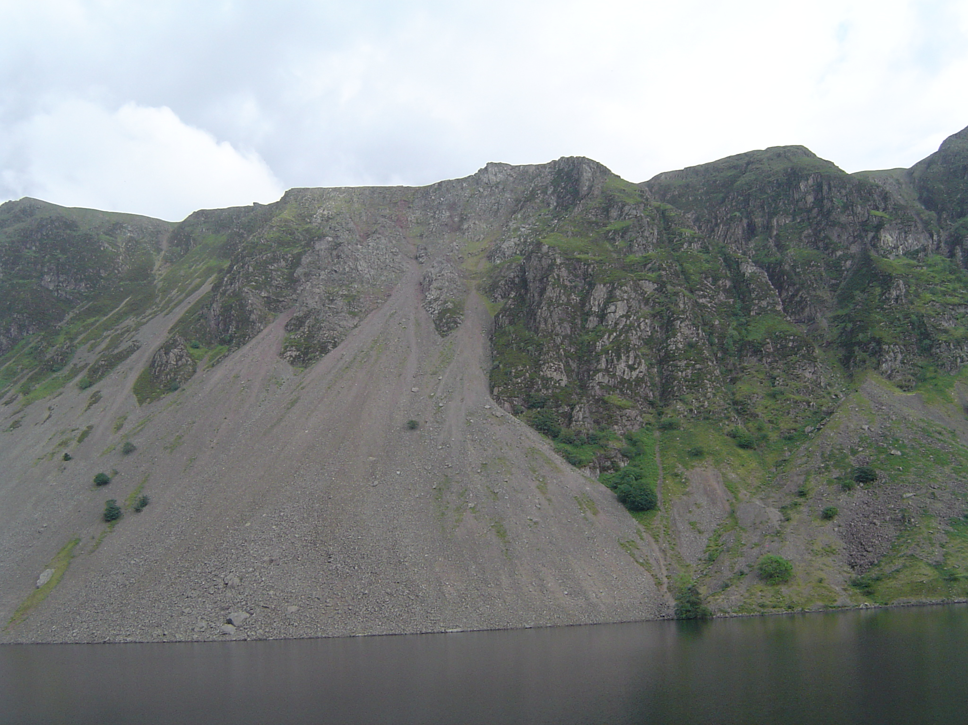
Party of 5 Cragfast – 17 June 2007
Party of 2 Cragfast – 11 July 2008
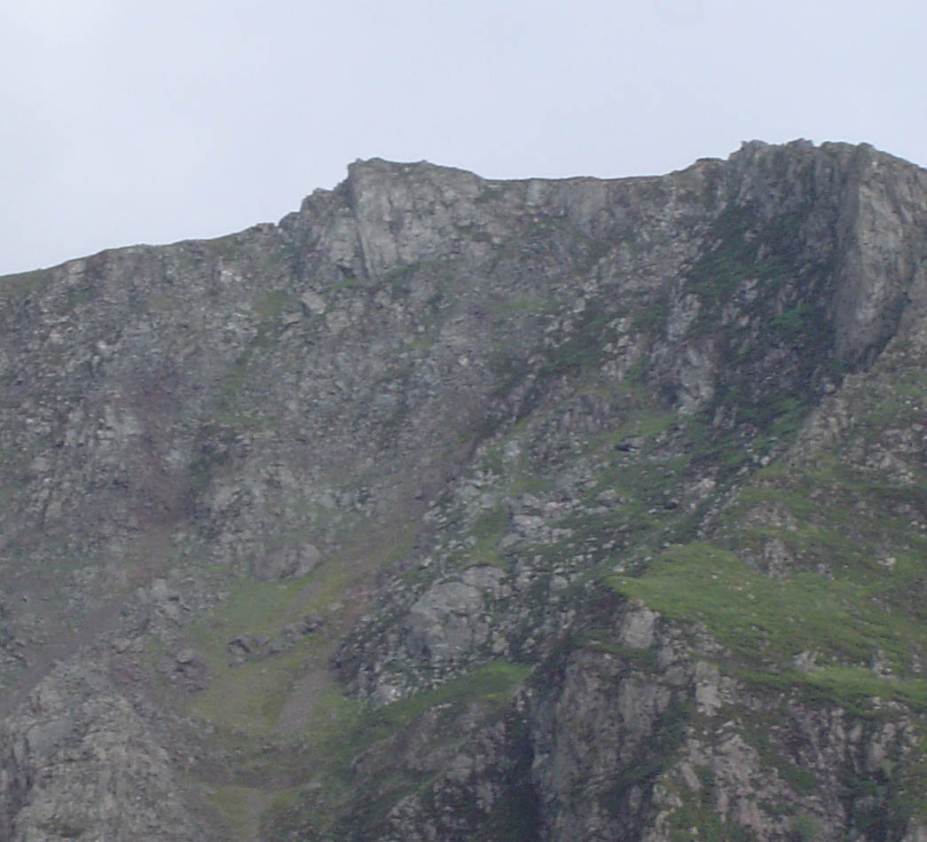
EXIT

