Shows the Sequence of Events

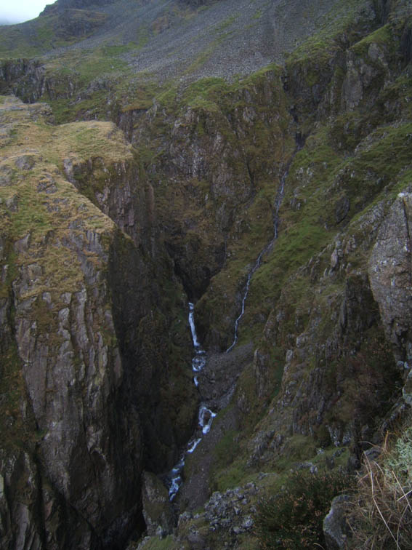
1
2
3
4
5
Four remain cragfast
here
Uncle follows and
falls 20m

Nephew
goes for help both scrambling and falling
- The two separate groups of three try to climb down Piers Gill following the beck down (One group includes a father, teenage son and teenage nephew)
- The six become cragfast, the nephew manages to climb down
- The Uncle follows and falls 20 m landing on his back but no major injuries
- The nephew makes his way down the gill bottom, scrambling through the gill until he comes to a large waterfall
- The nephew falls off the 15 m waterfall pitch into a deep pool and swims out, then scrambles down the remainder of the gill to raise the alarm. Very courageous

Nephew climbs down
Group of six make way down Piers Gill
Shows the Rescue Evacuations

Pendulum
Rescue 1 by 1
Fallen Walker

Rescue Belay
Casualty & Rescuer hauled up the 100m side wall of Piers Gill
- Two independent rescues – 15 involved in the 4 crag fast, 15 assisting the fallen walker – initially only 4 Wasdale MRT climbed down Straight Gill into Piers Gill from the Lingmell side. Cockermouth MRT members scrambled in from the head of Piers Gill
- 4 crag fast taken out horizontally one at a time, initially by pendulum until more ropes arrived with the Cockermouth team – then traversed and haul assisted up the waterfall pitches until eventually walked out of the top
- Fallen walker hauled 100m up the side of the Gill by two rescuers, one who was lowered in from the top
- Fallen walker walked (assisted) back down to Burnthwaite
Group made safe here
Evacuated up the Gill
2 rescuers
abseil down Straight Gill
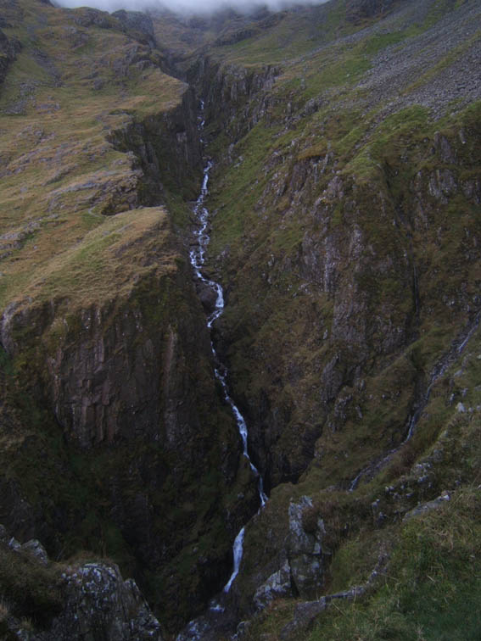
Fall Line
4 Evacuated up the Gill
Rescue Belay
Four cragfast
here

Rescue Spotter

