RACE REPORT - Lingmell Dash 2007

Bingley Harriers Rob Jebb has made his home in Burnside near Kendal and likes nothing better than plundering our Lakeland fell race course records. Robb did the business once more in the 4.5 mile 2500ft Lingmell event taking the record down to 45 minutes and 36 seconds. Almost three minutes adrift came Ambleside's Nick Fish who had been surprisingly pushed all the way to the summit by the emerging Rob Friend of the Wasdale Mountain Rescue Team. It was only Nick's superior descending prowess that saw him draw clear on the fall to the valley floor.
Cumberland Fell Runner on their home patch were well represented with Irvine Block first V50 home in 6th and Andy Fletcher in 17th stretching his legs after successfully completing the Wasdale race for the first time the week before.
The ladies category saw CFR's Lindsay Buck taking 11th place overall from to come home ahead of Warfdales Judy Howles and newcomer Tracy Malham in her first serious fell outing.
All funds raised for this race go directly to the Wasdale Mountain Rescue Team and Julian Carradice (Team Leader) who finished the race in 13th place thanked all the runners and local businesses such as Lingmell House, Wasdale Head Inn, Burnthwaite Lodge and the Barndoor Shop for supporting the race.

Position Name Time
1 Rob Jebb 45.36 NEW RECORD
2 Nick Fish 48.27
3 Rob Friend 53.35
4 Richard Wilkinson 57.11 1st vet. over 45
5 Phil Craker 57.36
6 Irving Block 59.07 1st vet. over 50
7 Ian Davies 62.17
8 Ben Crowther 64.10
9 Andre Vhis 65.51
10 Phil Walters 69.30
11 Lindsay Buck 70.03 1st Female
12 Chris Green 70.11
13 Julian Carradice 71.25
14 Judy Howells 71.50 2nd Female
15 Pete Mitchell 72.53
16 Tracy Malham 73.21 3rd Female
17 Andy Fletcher 74.29
18 Julia Fish 76.03
19 Pete Jebb 79.37
20 Colin Bostock 79.49
21 Sean Gauton 91.22
22 Kevin Holland 140.00

Total field - 23 - one runner retired

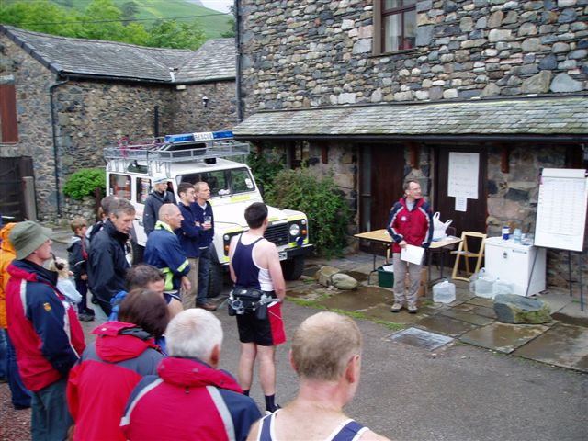

Julian Carradice, WMRT Team Leader presents the awards - Rob Friend – WMRT Team member came third with a very quick time 53 .35 (no photograph available)
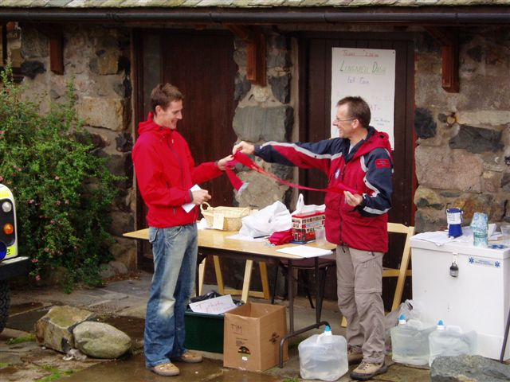

First Male runner – Rob Jebb – new record 45min 36 secs

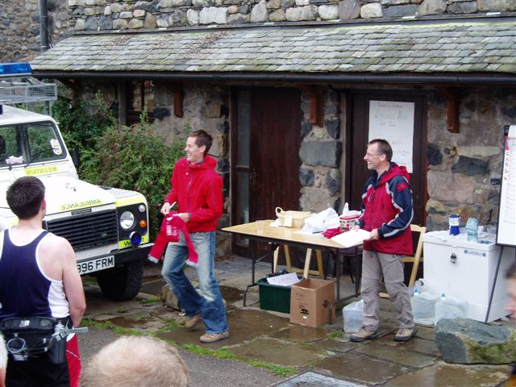

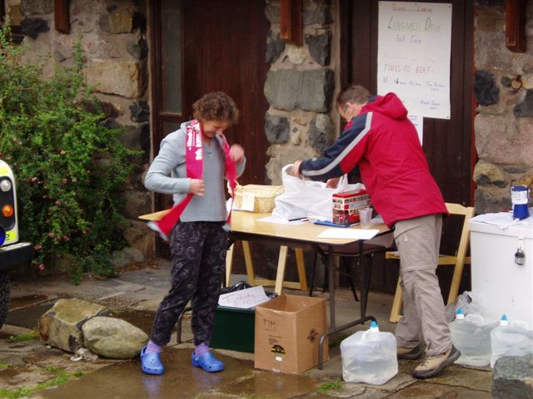

First Female - Lindsay Buck 70 min 03 sec

