Issued 25/8/06
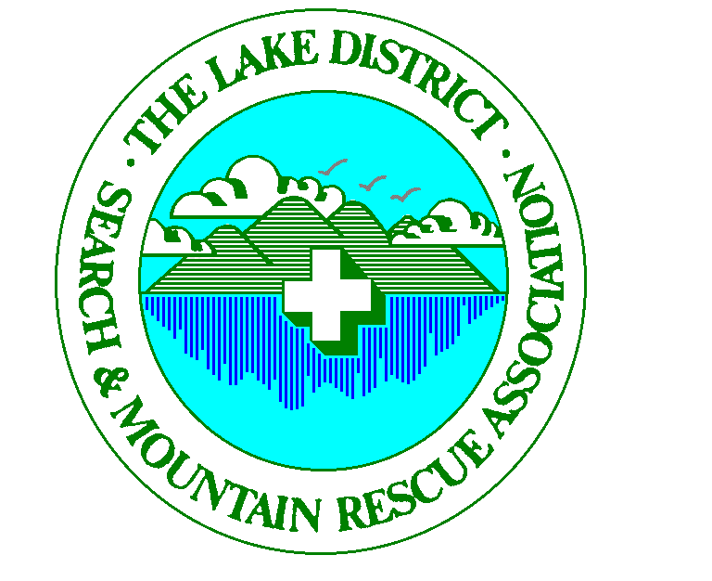

PRESS RELEASE – Embargoed until …Thursday 31st August 2006…………

Highest number of Mountain Rescue Fatalities on record in the Lakes – How can we halt this trend?

The Lake District Search and Mountain Rescue Association (LDSAMRA) has taken the unusual step of running a poster campaign throughout Cumbria to raise the public awareness of mountain rescue….what mountain rescue is and what it isn’t.

- Do you know how many teams there are within Cumbria serving their communities?

- Did you know that the 450 team members within those 12 teams covering the Lake District are all fully trained but unpaid volunteers?

- Did you know that it costs between £30,000 and £50,000 each year to cover the cost of running a single team? Collecting boxes are your way of keeping the service going and improving it.

- Did you know that team members are on call 24 hours a day, 365 days a year and most have full time jobs?

- Did you know that we are all quite happy to be purely volunteers and on call?

- Did you know that this year 57% of all calls were made via mobile phones? In many cases we struggle to get back to the informant as they move from their location or switch it off?

Even today, many people who walk the fells on a regular basis still believe that mountain rescue is a fully paid, full-time professional service funded by taxpayers.

In addition to the public’s limited understanding about what mountain rescue is and isn’t, or how they should call out a mountain rescue team, we are also concerned over the growing number of incidents and particularly fatalities. The poster campaign is a response to this and also to concerns within the mountain rescue community over the numbers of agencies that are becoming more and more involved in mountain rescue. This could be either as a support role i.e. Air Ambulance in preference to road ambulances; or the Maritime Coastguard Agency (MCA) taking over co-ordination of rescues on the four public access lakes; or the Fire and Rescue Service with swift water rescue and cliff rescue on the horizon.

THE UMBRELLA ORGANISATION OF THE LAKE DISTRICT MOUNTAIN RESCUE TEAMS - AFFILIATED TO THE MOUNTAIN RESCUE COUNCIL
REGISTERED CHARITY 506349 – GIVE AS YOU EARN 4184

With so many different organisations in the frame, the public can be forgiven for being confused as to who to call in the event of an off-road incident. In addition to all this confusion there are the extra demands being made on funding with different groups trying to meet their own particular funding needs.

How do we plan to increase public awareness and what will you see that is different? There will be posters located in every single outdoor shop, outdoor centre, hotel and community centre throughout the region. Also when you buy an item in a shop there could be a small credit sized card placed in the bag along with your purchase. This card will advise you on exactly what to do in the event of needing the mountain rescue service. This will hopefully lead to fewer delays in getting the correct emergency resource and equipment to you. This is especially important in life threatening circumstances where the team needs to get to you within that golden hour. If the team needs a helicopter then they will ensure you get the correct type of helicopter for the job.

The following accident statistics for 2005 in the Lake District have shown some worrying trends and LDSAMRA would like to reverse this trend.

Of the 395 incidents attended by the Lakes’ Teams in 2005, 19 fatalities were reported in mountain related activities, the highest figure on record. 10 were reported as 'collapsed' with medical problem, mainly heart related. It is interesting to note that in only two cases did companions attempt CPR (cardiopulmonary resuscitation). This must surely act as a wake-up call to hill users to learn basic life support; it is no use saying 'it will never happen to me'. Major trauma claimed 6 victims. Two rock-climbing deaths resulted from leader falls, one caused by a large rock fall on a popular crag. Both of these incidents occurred within eight days! The other four deaths resulted from falls on steep, rocky ground while hill walking. These occurred toward the end of the day, consistent with other accidents reported when people are becoming tired. This must be taken as a sign to improve people awareness that fitness levels are important in safe movement on difficult ground.

If you would like to know more about this voluntary service provided to your community, then it is worth paying a visit to the regional website which has links to all your local teams www.ldsamra.org.uk/ . There you find virtually anything you need to know about mountain rescue. Thank you for your support in the past and hopefully, your continuing support for the future.

This publicity campaign is being supported by the Cumbria Tourist Board and HSBC in the Community. We are extremely grateful to HSBC who have fully supported the project as part of their commitment to supporting the community.

John Dempster MBE
Chairman LDSAMRA

THE UMBRELLA ORGANISATION OF THE LAKE DISTRICT MOUNTAIN RESCUE TEAMS - AFFILIATED TO THE MOUNTAIN RESCUE COUNCIL
REGISTERED CHARITY 506349 – GIVE AS YOU EARN 4184
Notes to Editors:

The Lake District Search and Mountain Rescue Association is a registered charity and is the umbrella organisation for the 12 teams serving the Lake District. Its primary role is to act as a forum for sharing best practice within the region and a focus for mountain rescue communications between the national body and the individual teams. In addition to the 12 member teams, the Police, Ambulance Service, Fire and Rescue, RAF and Air Ambulances are represented at the association meetings. There are approximately 450 team members amongst the 12 teams of Cumbria and the cost of providing the service is through voluntary donations from the general public. Team members are all volunteers who give up their time to help those in need.

Attached to this press release are files of the posters and leaflets that are being distributed throughout the Lake District by the volunteer members and supporters. In total we are distributing 50,000 posters and 100,000 leaflet cards.

For further details please contact:

Richard Warren
Secretary LDSAMRA

rawarren@freenetname.co.uk

019467 85682 (day)
01946 62176 (evening)
07715 700 324 (mobile)
THE UMBRELLA ORGANISATION OF THE LAKE DISTRICT MOUNTAIN RESCUE TEAMS - AFFILIATED TO THE MOUNTAIN RESCUE COUNCIL
REGISTERED CHARITY 506349 – GIVE AS YOU EARN 4184

