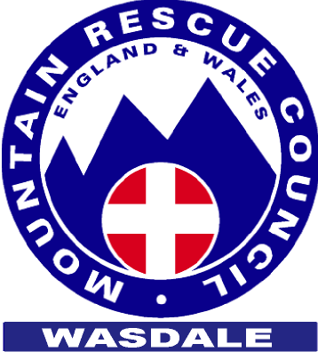

Wasdale PRESS RELEASE
Mountain
Tuesday 4 December 2007
Rescue
Yet another Three Peaks Challenge walker lost in Wasdale.

Team

Nature of incident and details of injuries:

The team were called at 0550 to assist a solo walker attempting the second mountain on the 3 Peaks Challenge. He had set off from Wasdale Head to climb Scafell Pike at 0100 but had lost his way, ended up on the wrong mountain and was unable to move from Lords Rake, a steep and unstable rocky rake running across the front of Scafell, the second highest mountain in England next to Scafell Pike. His description of his location was accurate but he was unable to find a way off without assistance. Two team members quickly located him and escorted him off the mountain.

For information sunset last night was1545, sunrise today was 0815.
Weather yesterday evening was cold with clear skies but with thick cloud and heavy rain moving in overnight as forecast.

Number of team members involved: 5
Duration: 5 hours
Further information:
Last year was the team’s busiest ever; we responded to over a hundred 999 calls and mobilised the team on 73. This year (we start our year from our AGM in mid November) looks like carrying on the same way. This is the fourth call to assist lost walkers in 5 days. The team is becoming increasingly concerned about the inability of fell walkers to navigate when they lose the path and their reliance on Mountain Rescue Teams to provide a guiding service. This is not just a Wasdale problem, have a look at Langdale Ambleside’s web site: www.lamrt.org.uk, 9 October 2007 for their comments.

For further information regarding this incident please contact the team leader, Julian Carradice on 07714 226609

