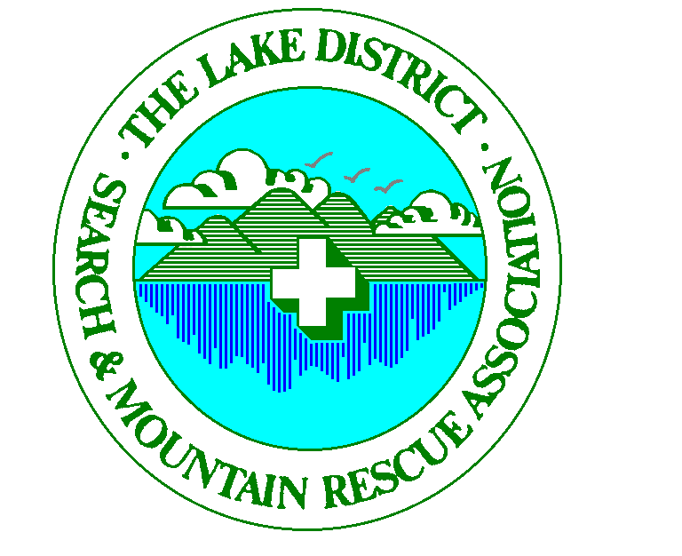
Registered Charity Number 222596
Registered Charity Number 506349

In Partnership with Where-Wolf.com

Increasing Public Awareness
Lake District Search and Mountain Rescue Association
Mountain Rescue (England & Wales)

Thank you for taking an interest…………..click on the following

- Safety Awareness Video 

- Background - Why we have a problem

- Article in Grough on the Problem

- Top tips

- Thankyou letter from a rescued family

Richard Warren
Chairman LDSAMRA

On behalf of MR(E&W)

THE UMBRELLA ORGANISATION OF THE LAKE DISTRICT MOUNTAIN RESCUE TEAMS - AFFILIATED TO THE MOUNTAIN RESCUE (ENGLAND & WALES)
REGISTERED CHARITY 506349 – GIVE AS YOU EARN 4184

