PRESS RELEASE
Issue 9/06/08
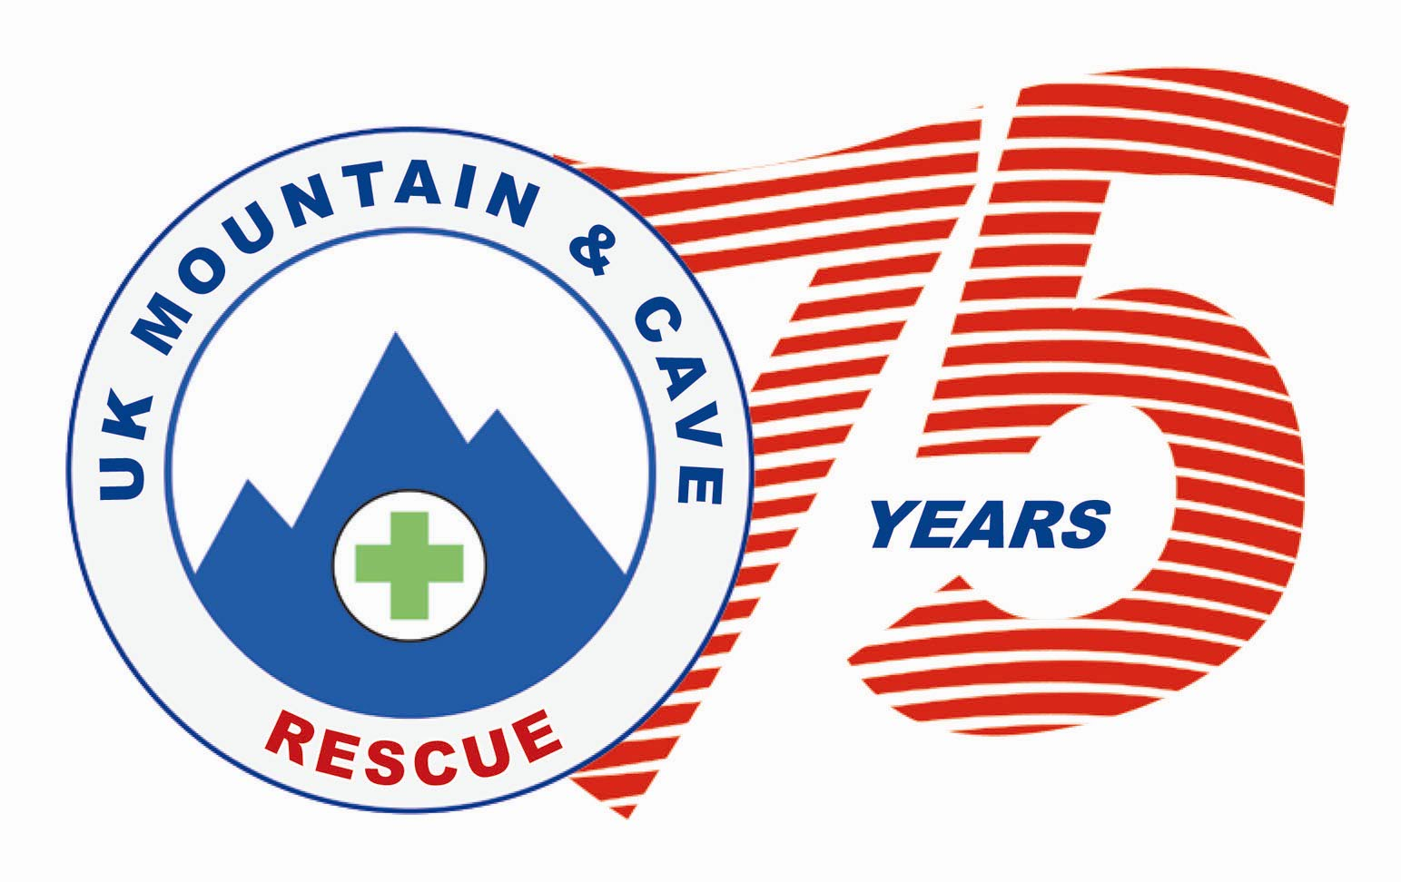
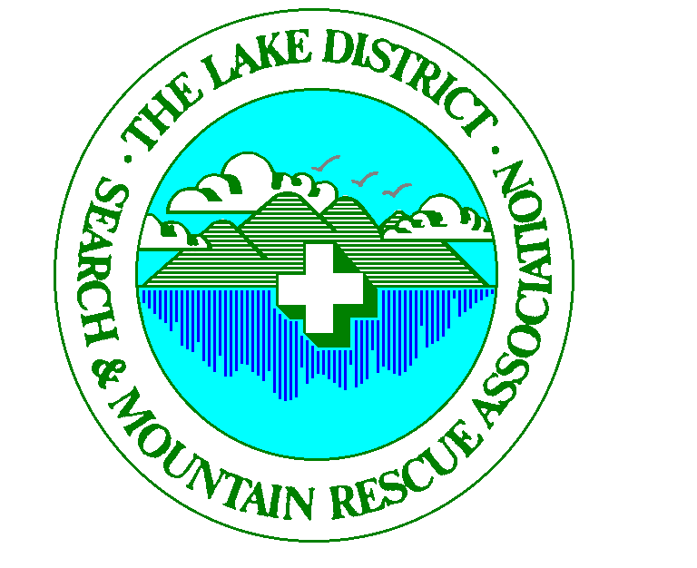

Mountain Rescue Teams Battled in the Rain to Raise Profile
Saturday 5th July 2008 - Ambleside

2008 is the 75th anniversary of the formation of mountain rescue in the UK and to mark the event the twelve Lake District teams organised an ‘It’s a Knockout’ on Saturday 5th July 2008 on the Ambleside Rugby Ground. The event celebrated the Lake District’s involvement over the past 61 years and gave recognition to the 450 rescue volunteers and their families who are totally committed to saving lives on the Lake District fells.

The event was officially opened by the Chief Constable of Cumbria, Mr. Craig Mackey. Mr Tim Farran, the local MP was also present to support the teams. In addition to the twelve Lake District MR teams there were teams from the RAF Leeming MRT and the Cumbria Constabulary Police recruits. There were a number of exhibitions and demonstrations relating to mountain rescue and the Langdale and Ambleside mountain rescue base was be open all day and formed an integral part of the day’s events, providing additional attractions. Key events were the crag rescue demonstration, search dog training techniques, river rescue, and of course the battle of the teams to secure coveted trophies – the main sponsors for the event were Sellafield Ltd., AMEC Nuclear, CH2M Hill, UKAEA Windscale who are all committed to improving safety both in the workplace and in the community. Lakeland Radio provided sponsorship and transmitted their programme live from the field. Many other local businesses provided either sponsorship, raffle prizes and a number of the local breweries provided barrels of beer for the evening social. Entrance to the event was free but donations were encouraged. Weather was appalling with driving rain but there were periods of sunshine where the public came out from under the gazebos to cheer on the teams in the It’s a Knockout competition. Overall the day was a great success and raised over £1,500 for the teams. Patterdale MRT won the It’s a Knockout competition and the RAF MRT won the best agency team.

A group of five 16 to 19 years old from the Centrepoint charity were invited across from the north east to join in the celebration activities on the Saturday and be taken on a walk up Aira Force Waterfalls on the Sunday. HRH Prince William of Wales is royal patron to both Mountain Rescue (England & Wales) and Centrepoint and actively encourages sharing of experience amongst his chosen charities. He was delighted to learn that Centrepoint were included in the weekend’s celebration.

Mountain Rescue is being strongly supported by Cumbria Tourism, The Lake District National Park Authority and Cumbria Constabulary throughout 2008 to raise public awareness of the voluntary nature of the service and the need for walkers and climbers to take greater responsibility when venturing on the hills. To reinforce the safety awareness messages, Mountain Rescue (England and Wales) were represented at the event and launched “Call Out Mountain Rescue” the new pocket guide to safety on the hill that provides the most up to date information on how to keep safe on the UK’s mountains. The day’s events were a striking platform to launch both the celebration of 75 years service and raise public awareness.

Richard Warren
Chairman LDSAMRA
THE UMBRELLA ORGANISATION OF THE LAKE DISTRICT MOUNTAIN RESCUE TEAMS - AFFILIATED TO THE MOUNTAIN RESCUE COUNCIL
REGISTERED CHARITY 506349 – GIVE AS YOU EARN 4184
Notes to Editors:

The Lake District Search and Mountain Rescue Association is a registered charity and is the umbrella organisation for the 12 teams serving the Lake District. Its primary role is to act as a forum for sharing best practice within the region and a focus for mountain rescue communications between the national body and the individual teams. In addition to the 12 member teams, the Police, Ambulance Service, Fire and Rescue, RAF and Air Ambulances are represented at the association meetings. There are approximately 450 team members amongst the 12 teams of Cumbria and the cost of providing the service is through voluntary donations from the general public. Team members are all volunteers who give up their time to help those in need.

Mountain Rescue (England and Wales) is the national body covering south of the Border. Mountain Rescue Committee (Scotland) is the co-ordinating body for the Scottish mountain rescue teams.

Facts about Mountain Rescue

- There are 61 teams with 3,500 team members covering England and Wales
- Team members are on call 24 hrs a day every day of the year
- All team members are volunteers and do not get paid
- Majority of team members have day jobs
- Both men and women are actively involved in mountain rescue
- Training and rescuing demands a very high commitment from the team members
- Tremendous support and understanding is necessary from partners, wives, husbands, family and employers
- Teams are self sufficient but are charities will hardly any external funding
- Teams need to raise around £30,000 to £70,000 each year to keep going
- Funding comes from donations and fundraising activities
- There are over 700 rescues each year, over half in the Lake District
- A typical rescue may involve up to 20 team members for around 6 hours on average
- Rescues are split 75% / 25% between trauma & medical / searches
- Helicopters do assist, but are only called for a relatively small percentage of rescues where urgent air support is required and weather conditions allow

Attached Photos

4083 – MRTs have photo opportunity with Great North Air Ambulance overhead
4094 - The It’s a Knockout (IAK) teams
4577 – Centrepoint young adults with members of the MRTs
4586 – Patterdale MRT wins the 1st Place trophy for the IAK
4594 – Centrepoint group with MRT members at Aira Force, Ullswater

For further details please contact:

Richard Warren - Chairman LDSAMRA

rawarren@freenetname.co.uk

019467 85682 (day) - 01946 62176 (evening) - 07715 700 324 (mobile)
THE UMBRELLA ORGANISATION OF THE LAKE DISTRICT MOUNTAIN RESCUE TEAMS - AFFILIATED TO THE MOUNTAIN RESCUE COUNCIL
REGISTERED CHARITY 506349 – GIVE AS YOU EARN 4184

