Piers Gill, Scafell Pike – Wasdale’s Newest Incident Blackspot

The Latest Rescue in Piers Gill caused quite a stir in the media but was it an ‘Insane’ climbing expedition ? – here are the facts from the Deputy Team Leader who arrived on scene.

‘A baby of 14 months became the youngest person to be rescued from England’s highest mountain after his family embarked on an “insane” climbing expedition.’ Times Online - 21/2/07.

Many of you will know something about this rescue already as it was very widely reported. The comment about it having been “insane” apparently came from a walker who was interviewed at Wasdale Head the following morning, as he prepared to set off for a walk. In contrast, Wasdale MRT went to a lot of effort to ensure the reporting was factually accurate but this article may fill in some of the gaps.

The call came at 19.30 on 19/2/07. The previous day had been glorious and warm T-shirt weather, and I’d even bumped into one of our team doctors carrying his baby in upper Mosedale that afternoon. Today had been different: cooler, more wind, low cloud, and rain in the afternoon, but still unseasonably mild for mid-February. It had been dark by 18:00.

A couple with their baby in papoose and a 5 year old on foot had set off at noon from Wasdale Head up Brown Tongue onto Scafell Pike. By chance they got into conversation with another unrelated party ascending the same route who subsequently raised the alarm when they noticed their car still parked after dark. These informants had even gone part way back up the fell to see if the family could be found.

The family had last been seen at 16.00 shortly after leaving the summit. The group was vulnerable so a fast find was important. Our numbers were reduced due to half-term so Duddon & Furness MRT were covering the Eskdale exits, a favourite place for ending up after navigational errors on the summit plateau, and Keswick MRT, despite having already been out that afternoon, would cover the Borrowdale side. We were sending small party groups up all the likely Wasdale exits and more dogs were on order.

My group took the path up the true right side of Piers Gill, a deep vertical-walled cleft, which sometimes sucks people in from the Corridor Route but has no walkers exit below this. Visibility was poor when we made contact with a party beneath us and it was difficult to tell whether they were on the true left bank above the crags or in the bed of the Gill, but neither are good places for small children. We left one of our party as spotter/radio relay to keep in contact and the remainder moved up to the Gill top then back down to cover both options.

We got to the family in the bed of the Gill (NY212082) at 23:00 and erected a bivvy tent. They were cold and wet but well dressed and unharmed, so not at immediate risk and a leisurely evacuation could now be considered. The parents were mortified and continually apologised from the outset. They were experienced walkers but had made a navigational error and entered the Gill, and then compounded it by pressing on hoping that there was a way out lower down, rather than retracing their steps up the rocky bed of the Gill. As soon as they had realised their mistake they had protected their children well and had stopped and sheltered when the going got too risky, before the big pitches lower down. They did not know who had called us out as no one was expecting them, and had left their survival bag in the car. The 5 year old was a bit quiet but perked up when offered a Mars milkshake, the baby was warm in a fully enclosed papoose but polished off a bottle of orange isotonic through a sports nozzle. We rewarmed and fed on sheep droppings (chocolate raisins) whilst the team assembled around us.

The best route out for small children from the Gill bed was not clear: either a rope haul up the side or assisted walkout/carry up the Gill to the exit some 100m/0.4km higher. We decided to try the latter and see how it went as it was important to keep the family together if we could. Baby went on the back of a sure-footed team member, and the 5 year old was carried across the pools and lifted up the steepest sections in a chest harness with supporting slings. The 5 year old went remarkably well but not surprisingly was tiring, so we decided to stretcher him off from the Gill top - it would be both quicker and safer. Keswick MRT kindly carried up the stretcher from the Styhead box and met us there. The way off now was a short uphill carry to Lingmell Col and then down to the valley bottom in stiff wind and rain by 04.00, to a very warm welcome from the Wasdale Head Inn. Not a technically difficult or adrenalin inducing job, but more satisfying than most.

Press interest was intense from the start and we reported the event factually and non-judgmentally. As far as I am aware no member of MRT present on the job criticised the parents personally: the parents were only too aware of their mistakes. They’d certainly been extraordinarily lucky in having us called out early that evening, but anyone can make a mistake and they’d done their best by their children thereafter. It’s good that the incident was widely reported, that others may learn from their experience, but were the parents ‘insane’? The implication of some reports is that the hills are no place for children no matter what margin of safety is applied. I used to take my children up hills at the same ages and I haven’t been locked up yet. I fear that some of the reporting will put off other parents taking their children (safely) into the hills for fear of public criticism, and in my view this would be a great shame.

David Willey
Deputy Team Leader
Wasdale MRT

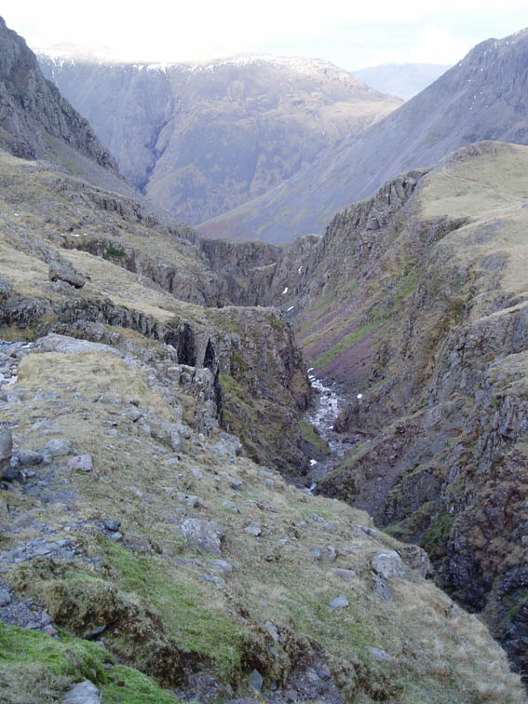

Piers Gill from the Corridor Route in better visibility

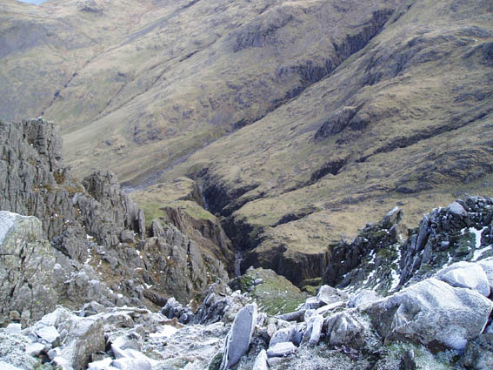

Looking down Piers Gill from Lingmel Crags – looking north-west down the line of Straight Gill

